**Vanier College**

**Computer Science Department**

**Project Report**

**Student Name: Yao Wu & Zheng Xue**

### Student Id: 2395031 & 2395035

**Teacher: Kawser Wazed Nafi**

**420-942 VA: Application Development 1 (Desktop) (Sect.01222)**

**College Library Management System**

**1. Work In Progress**

1. **Overview of implemented functionalities**

**Overall, we have completed 70% of the project.**

**In our work directory, we have a total of 12 WPF (Windows Presentation Foundation) applications and two independent classes, ( AdminOpr , UserOpr). All user interfaces (UI) have been successfully designed and completed. The database connection has also been established, resulting in a total of 14 classes in our project. At this point, we are pleased to report that we have already completed 9 of these classes. Highlighted in red are the components that have already been successfully implemented and completed.**

1. **Screenshots of WPF interfaces**

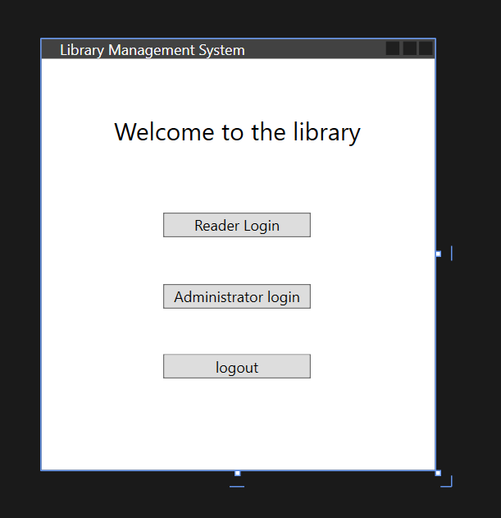

**Administrator part:**

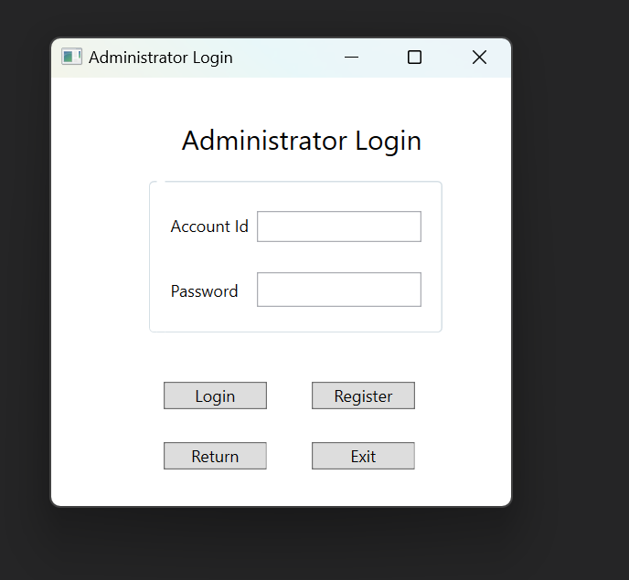

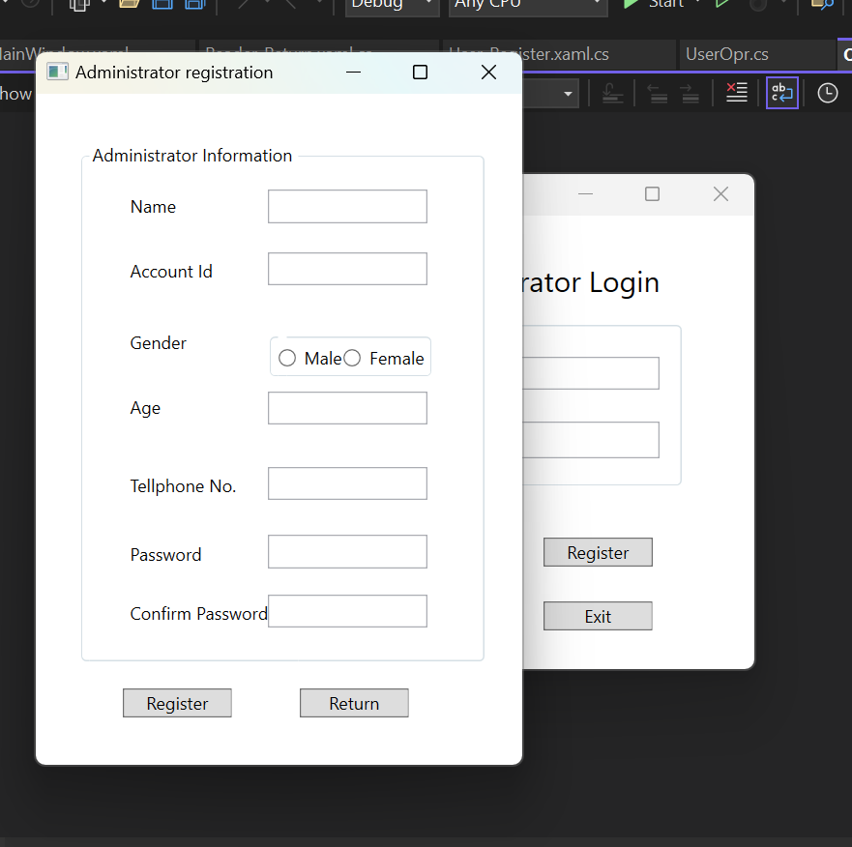

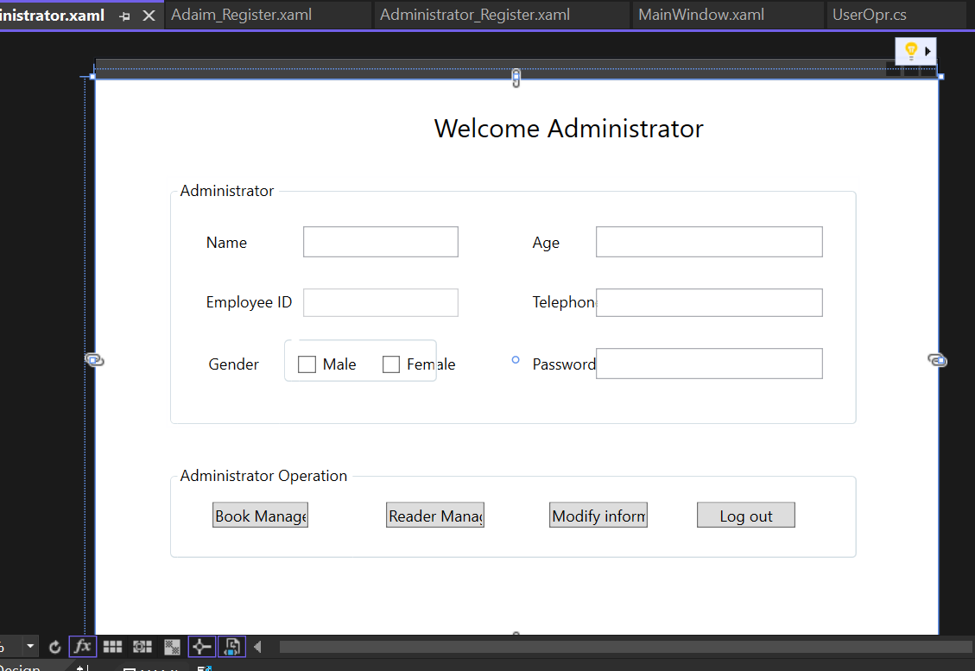

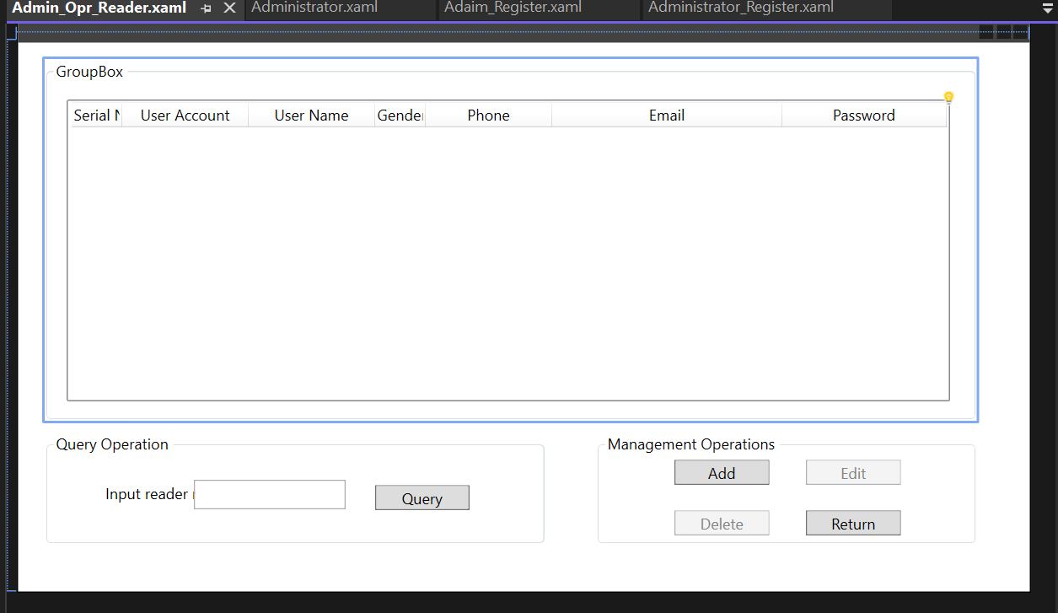

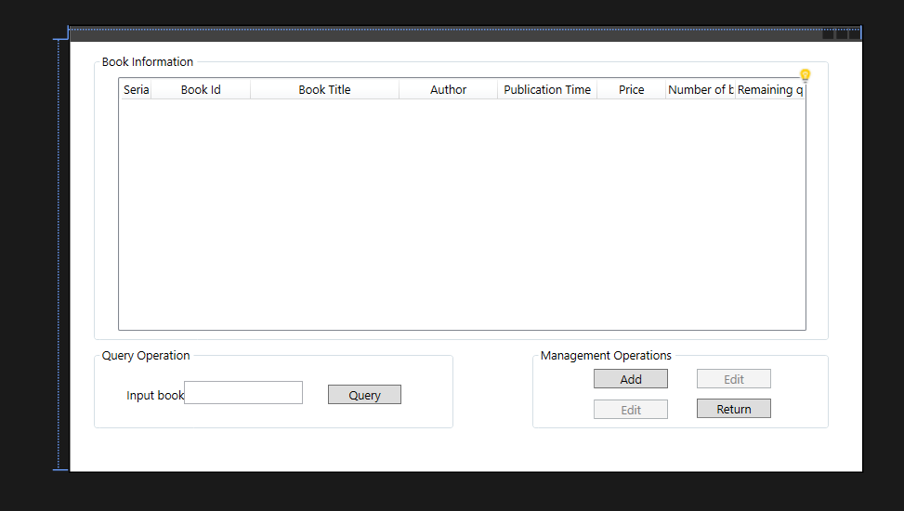

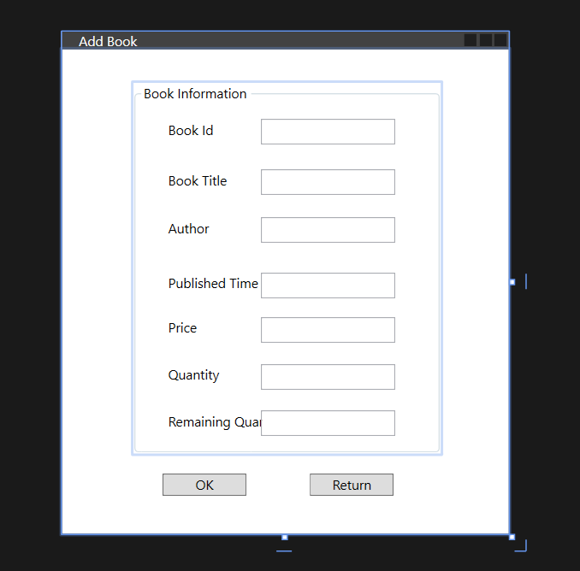

**Reader part:**

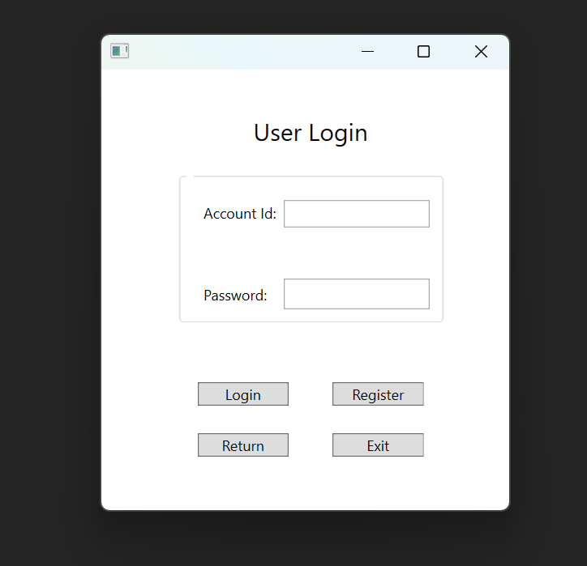

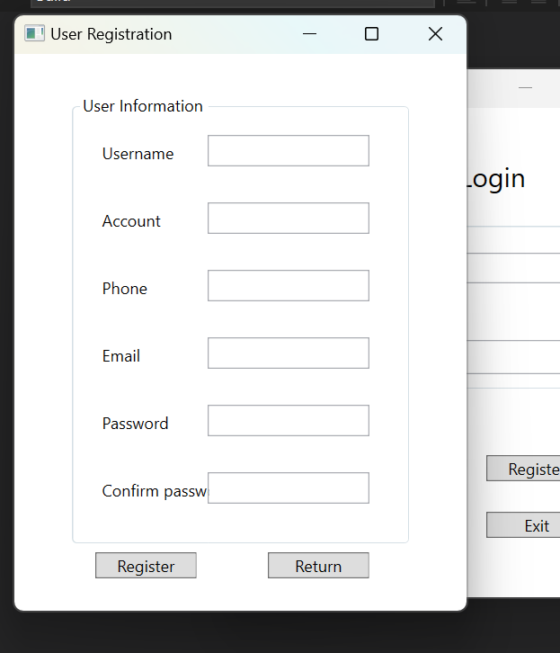

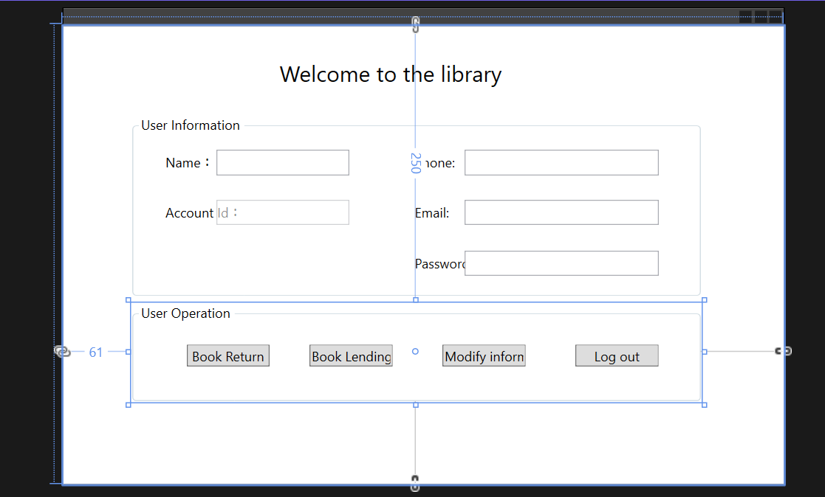

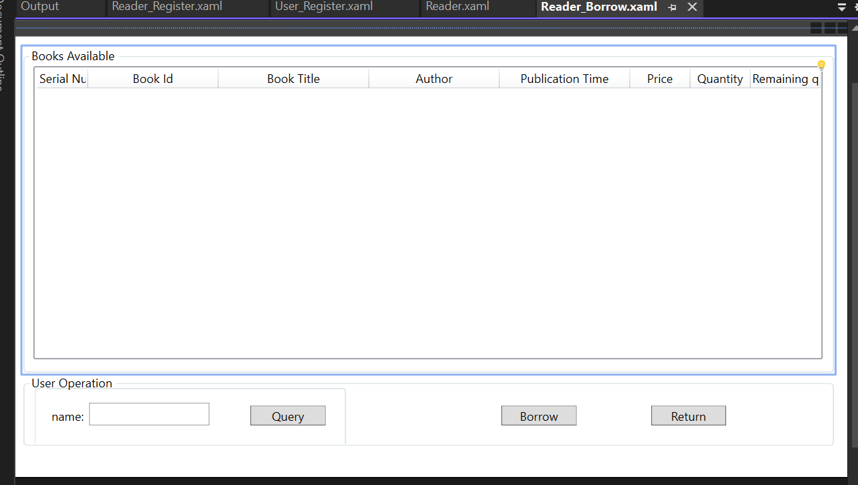

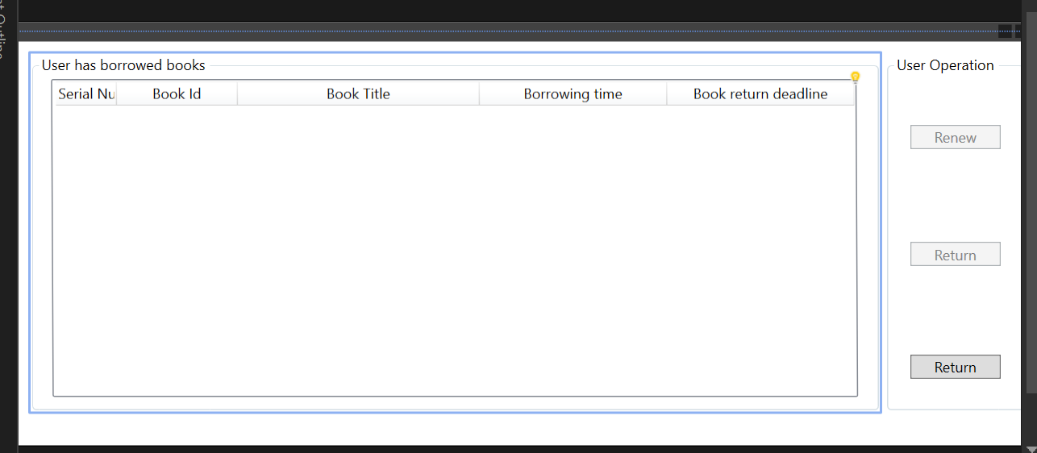

1. **Screenshots of working steps**

**Username is incorrect, login failed**

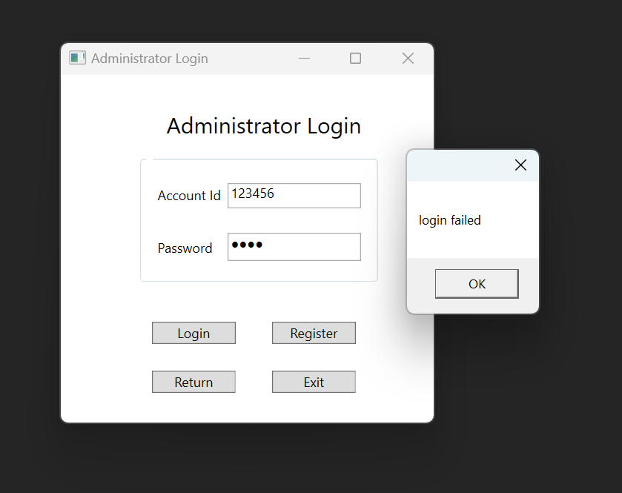

Username and password correct, jump into administrator page

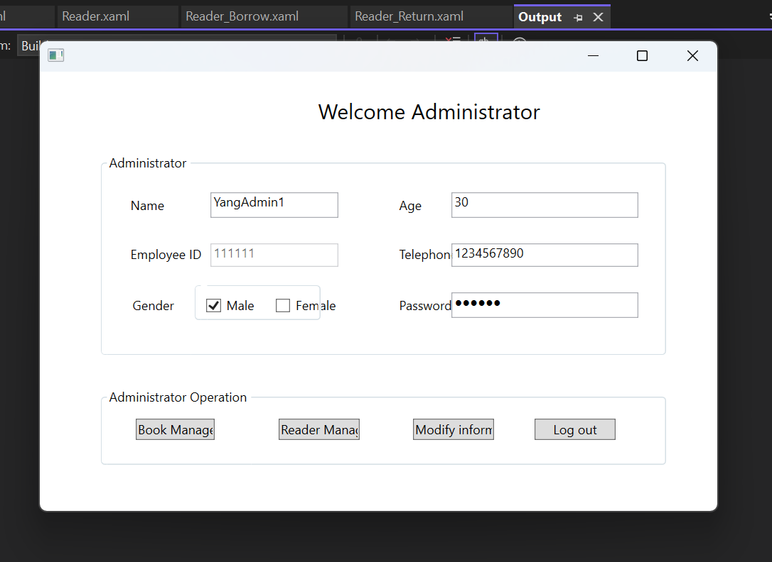

**Modify age into 20**

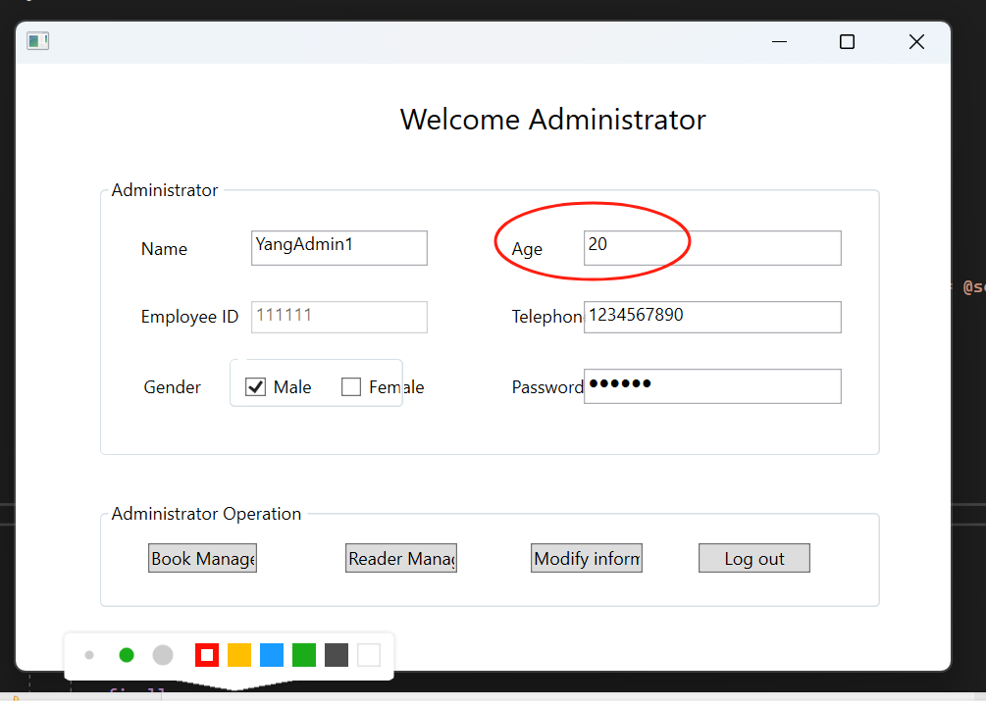

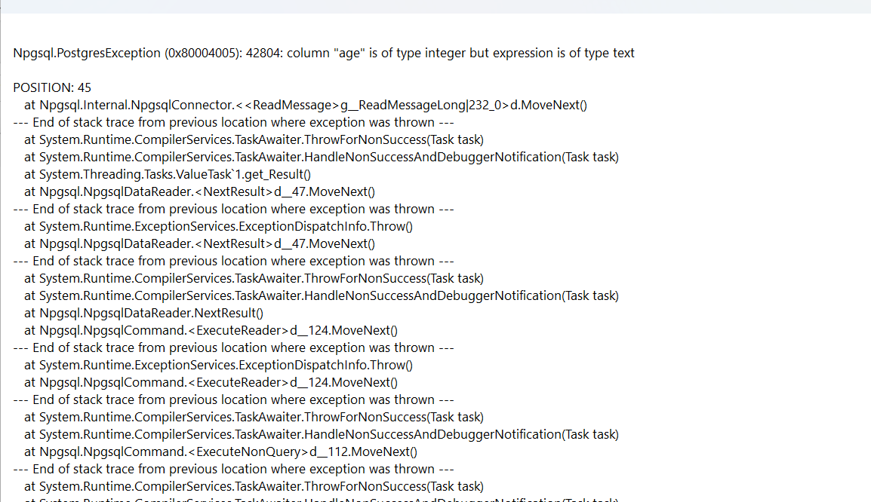

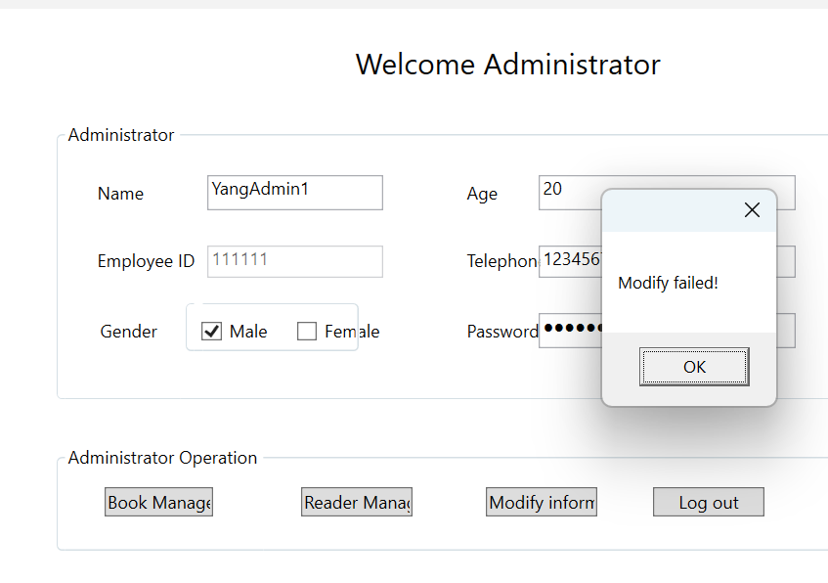

Some error, need more time to debug it.

1. **Completed codes:**

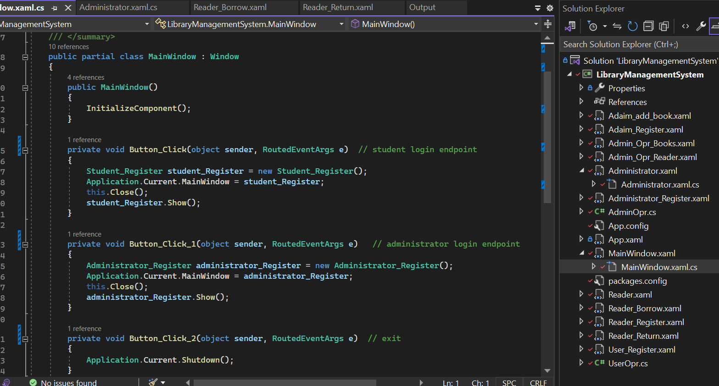

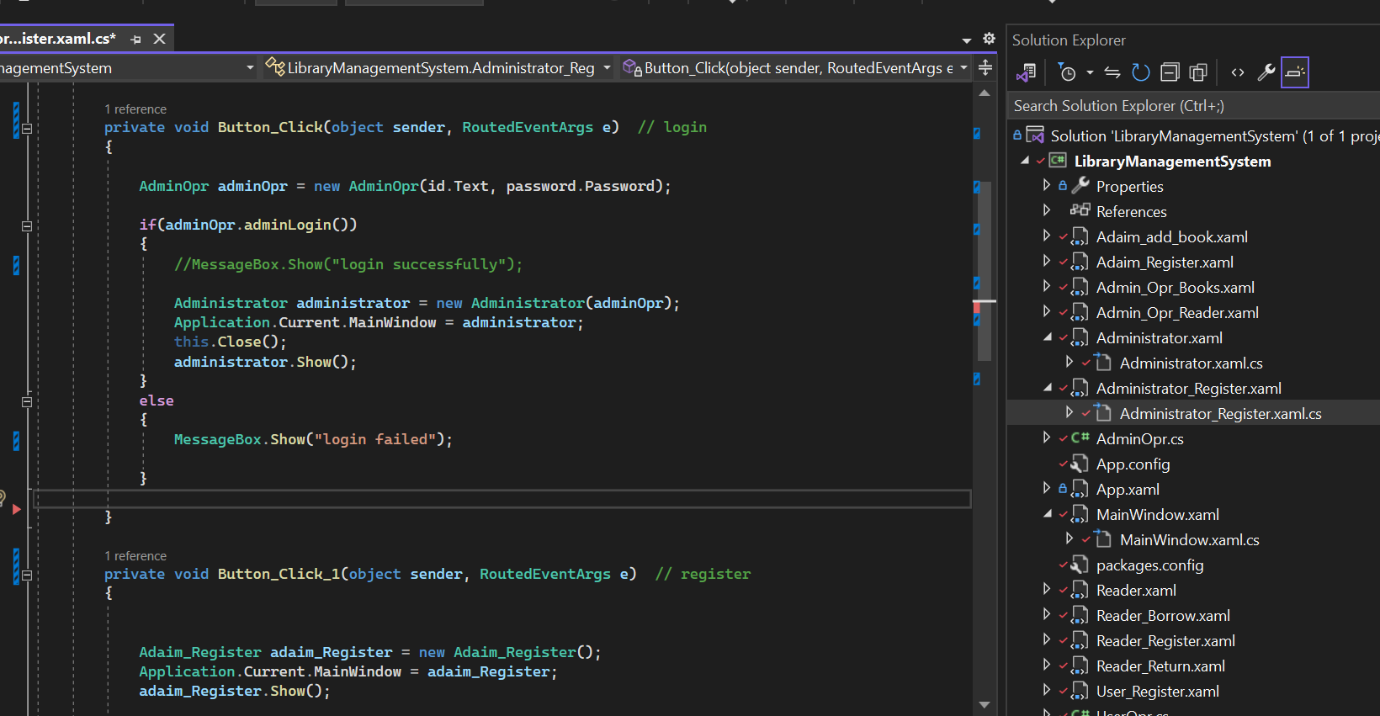

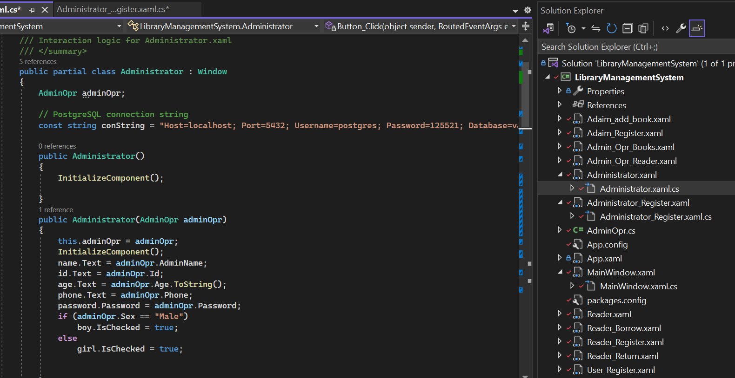

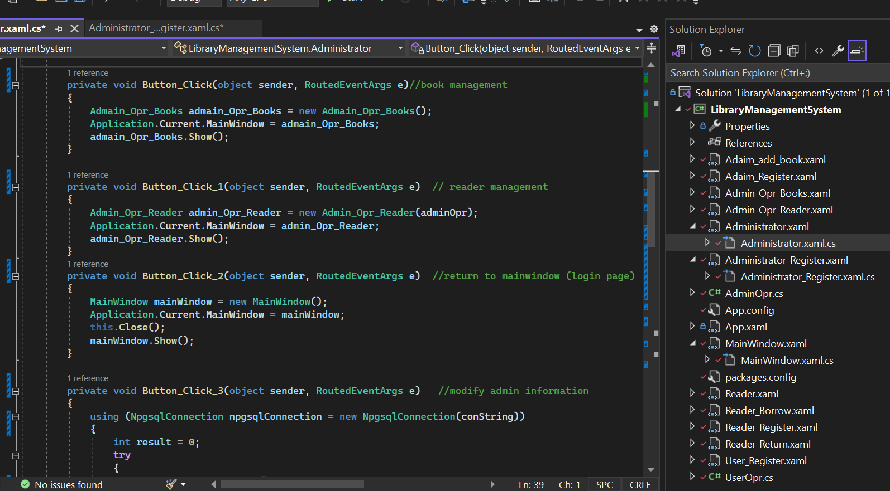

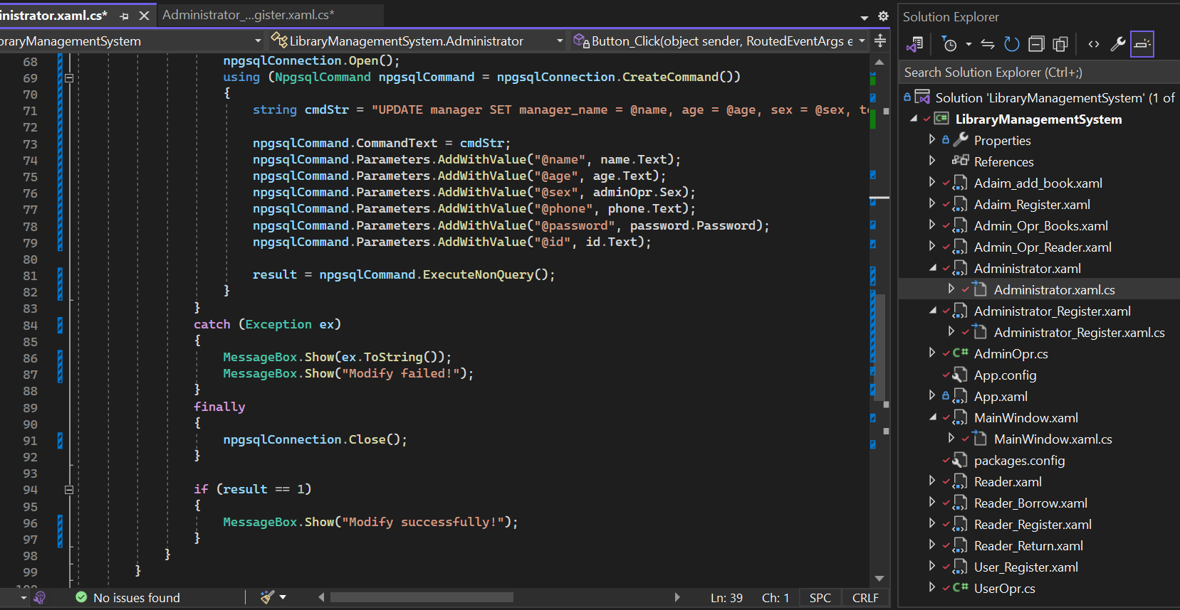

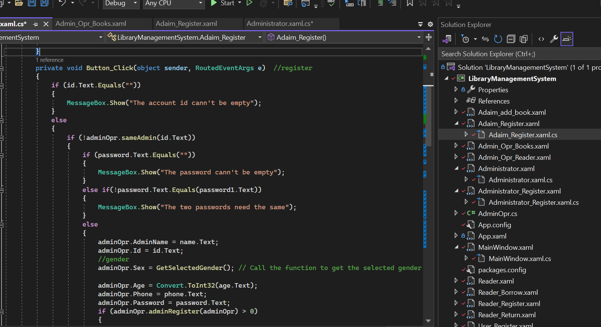

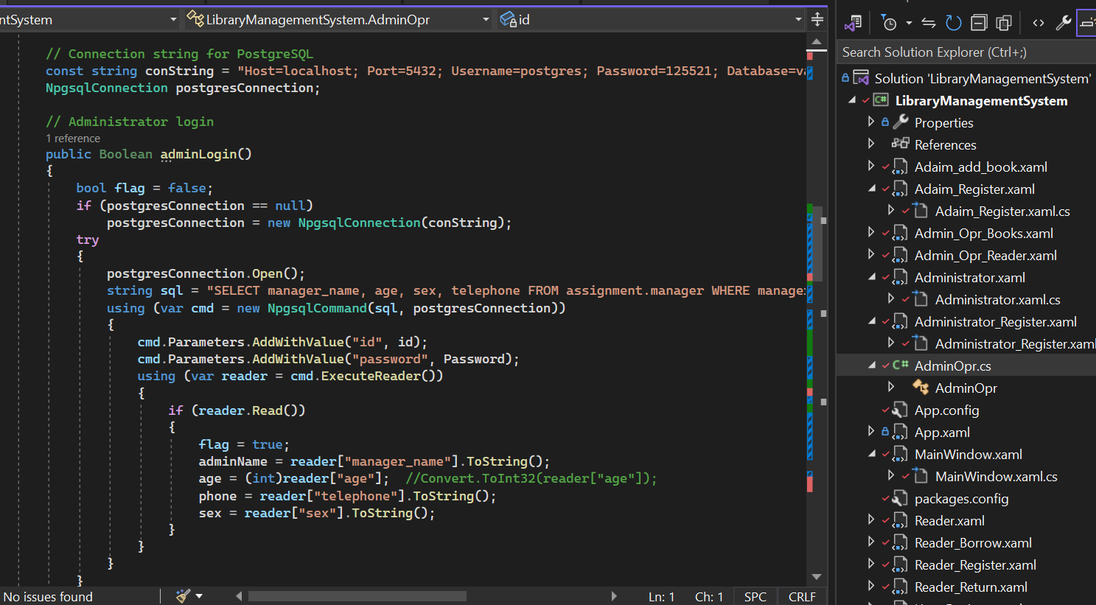

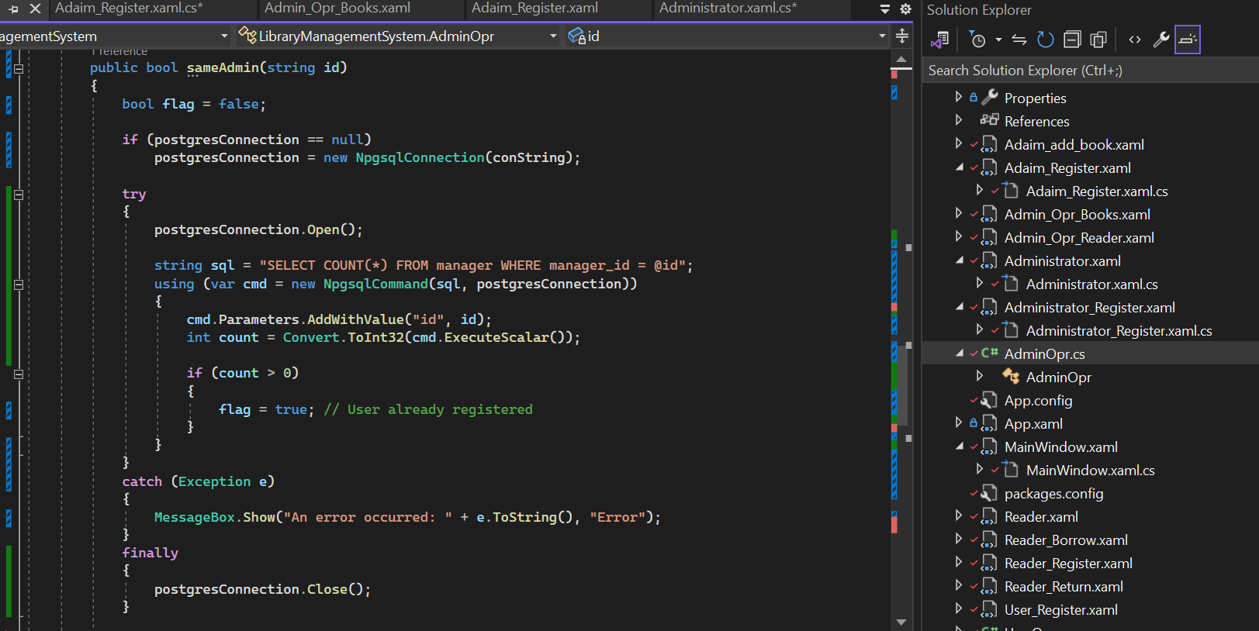

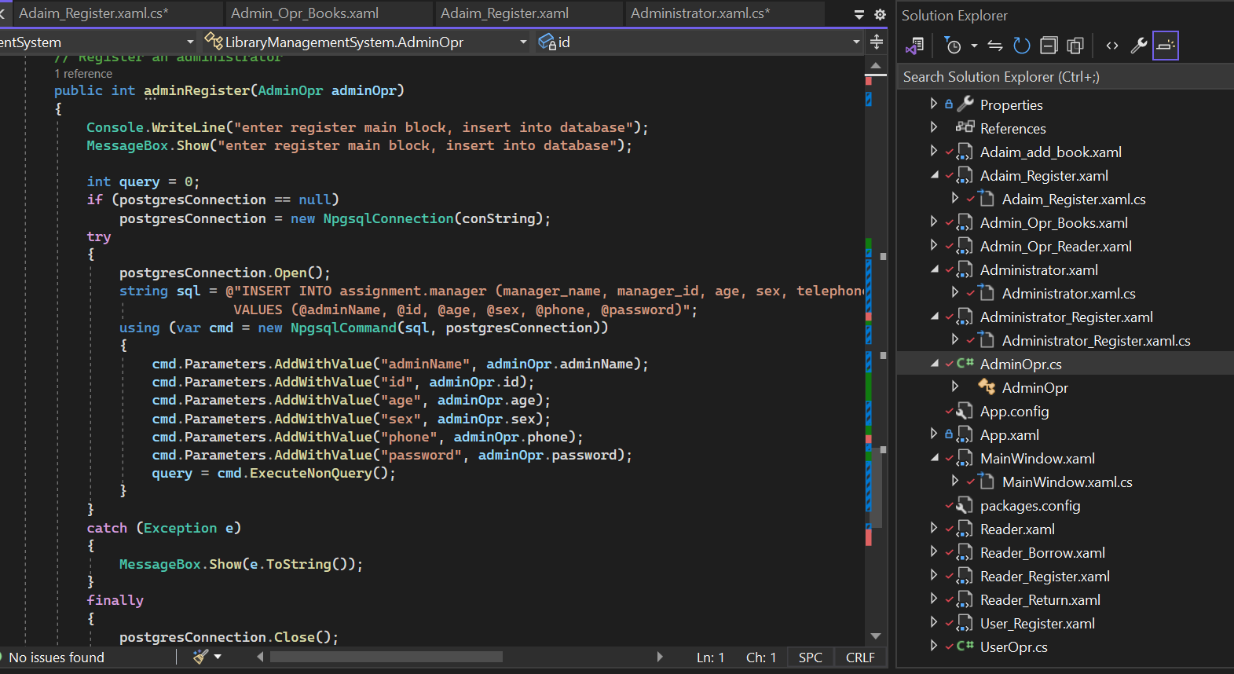

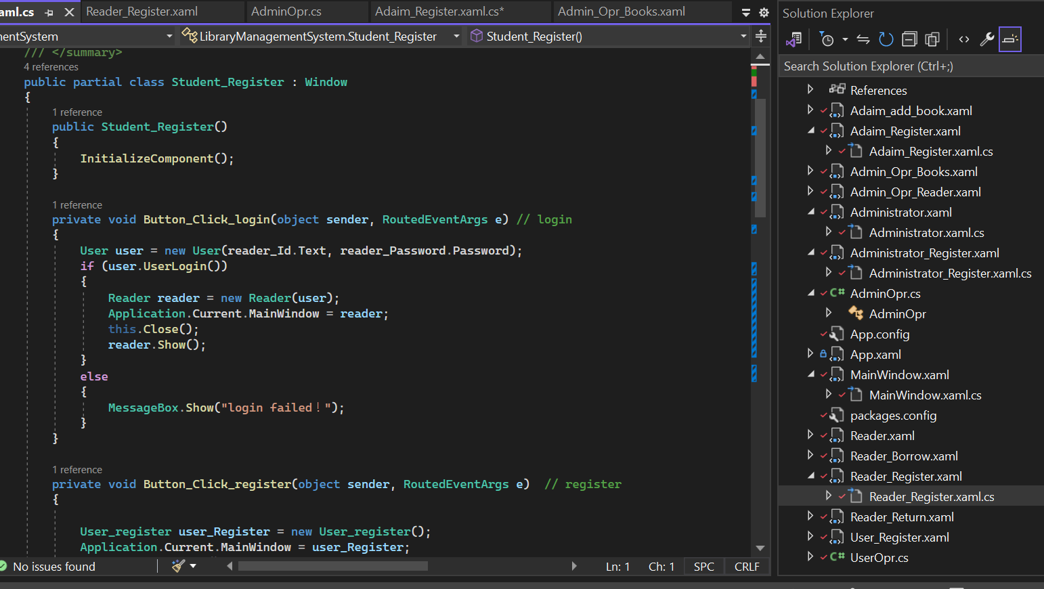

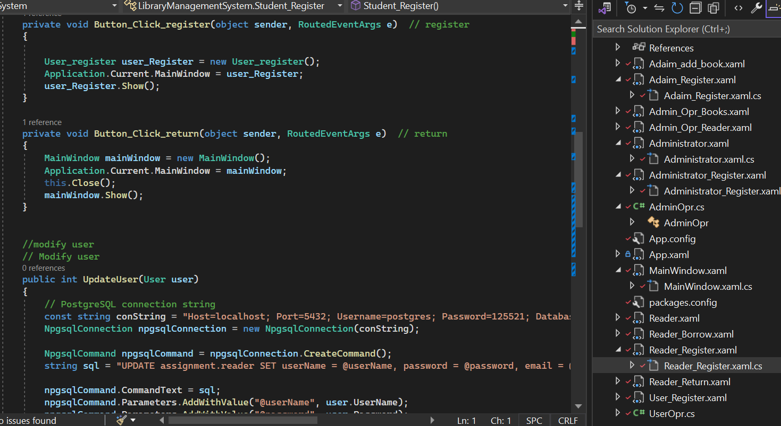

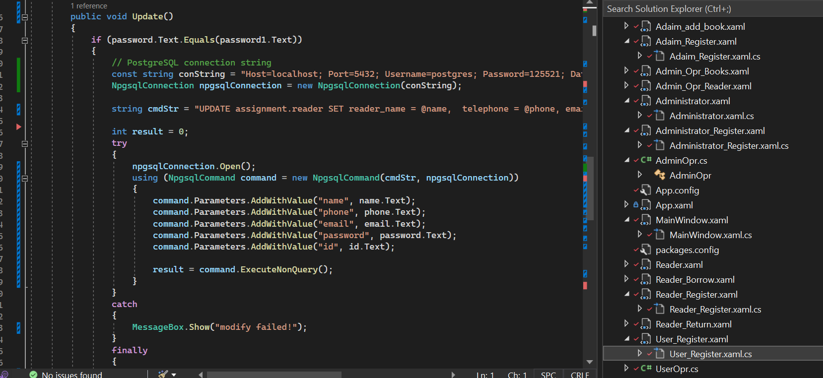

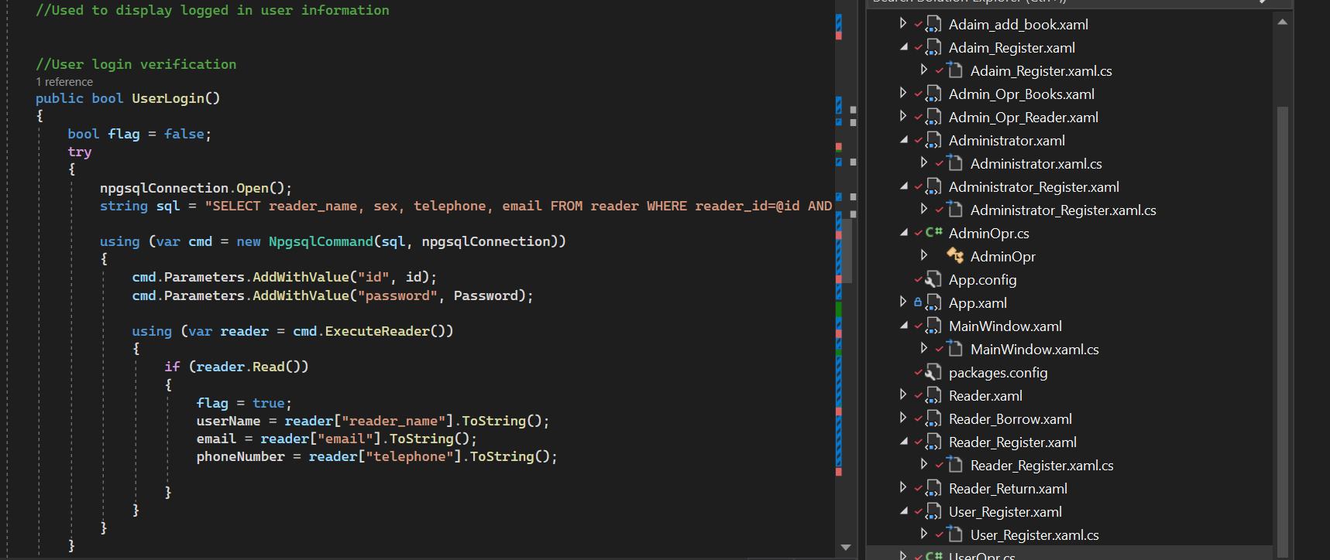

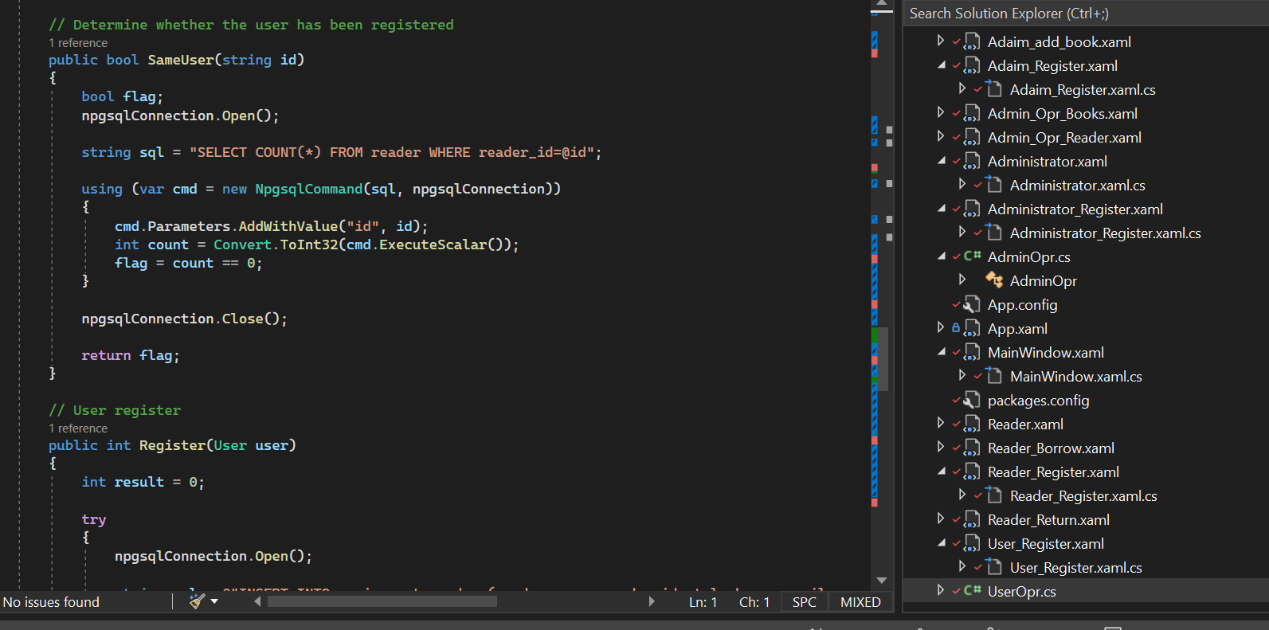

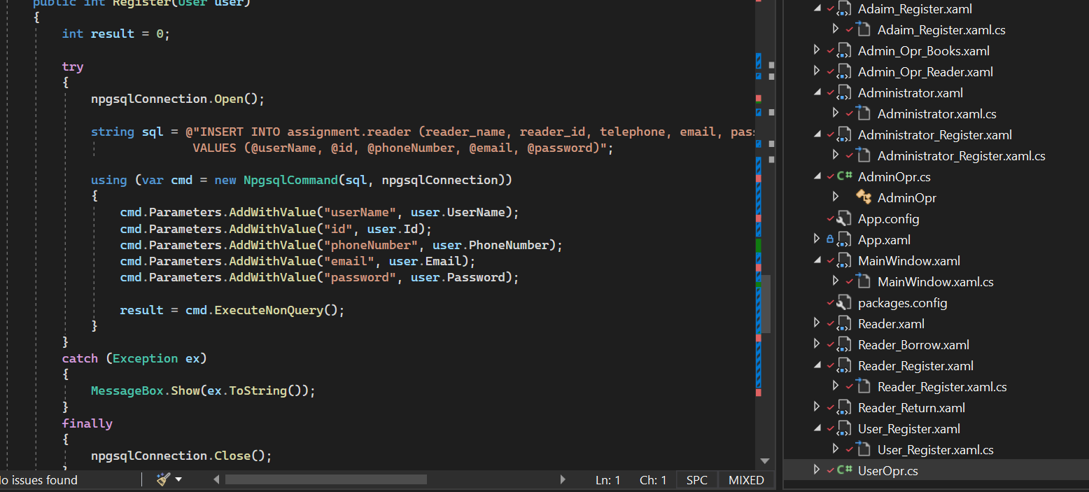

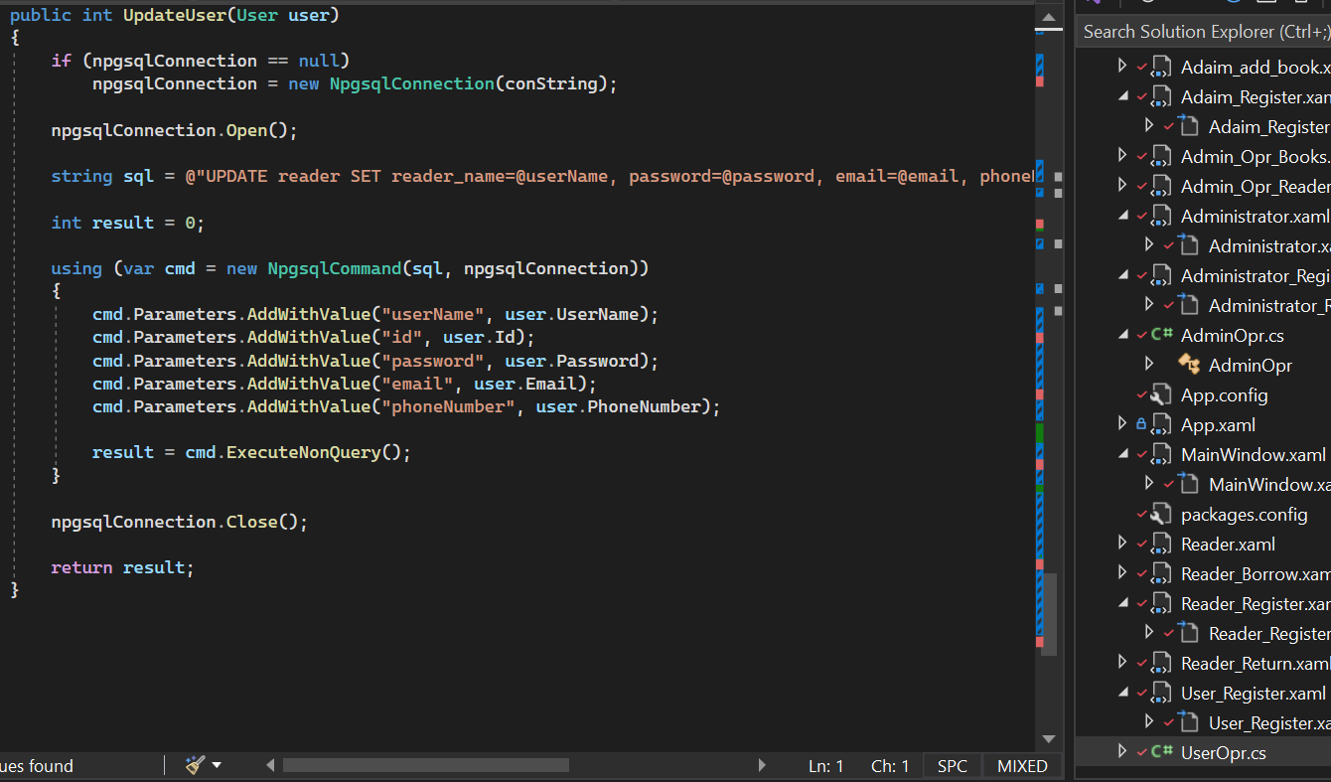

1. **Screenshots of database table entries**

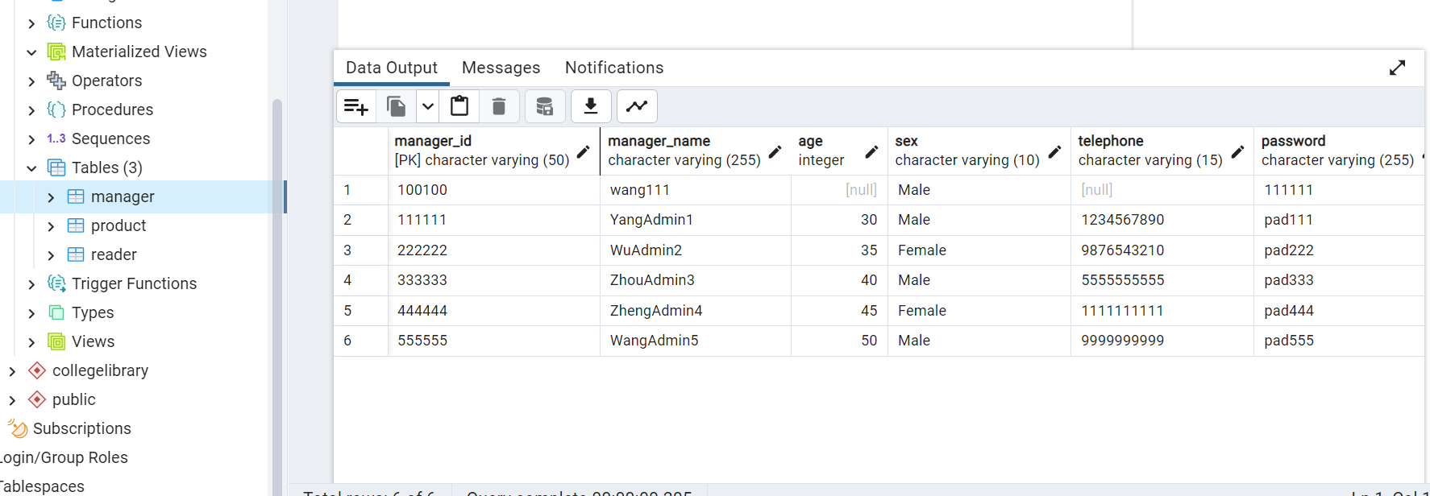

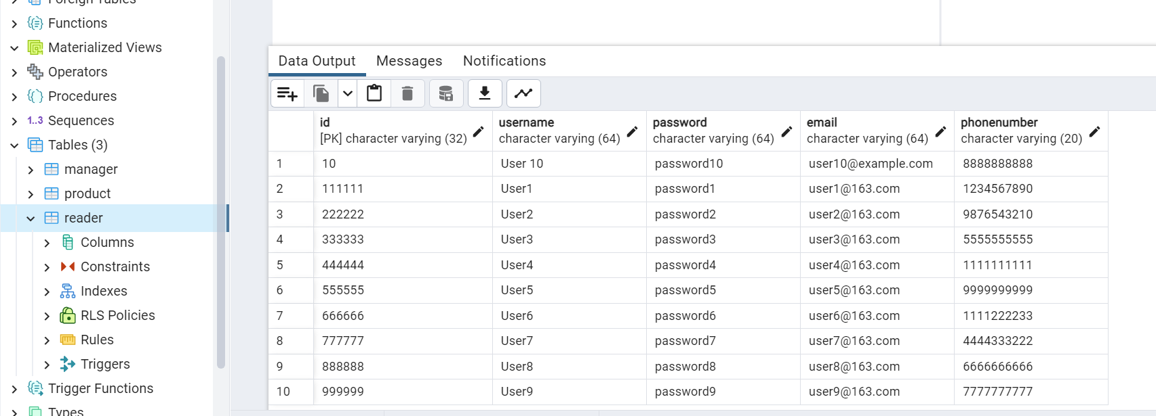

**2. Tools Finalized**

Development Platforms and Software Applications:

Development Platform: We develop our system using Microsoft Visual Studio 2022 version 17.7.4.

Programming Language: Our primary programming language will be C#.

Database Management: We utilize PostgreSQL for robust data storage and management. We use pgAdmin4 v6.21 and PostgreSQL 15.

User Interface: The user interface will be built using Windows Presentation Foundation (WPF) to provide a modern and intuitive experience. We use .NET Framework4.7.2.

Version Control: We will use Git and GitHub for version control to facilitate collaborative development and code management.

**3. Plan Details**

**Work Plan:**

**Week 7-8** (Core Functionality Implementation, Testing and Bug Fixing): Weeks seven and eight will complete all coding work and connect to database for test (Till now we have completed 90% work). We will conduct testing and bug fixing to ensure a stable system.

**Week 9** (REST API migrating): Week nine will migrate the database to REST API based database.

**Week 10** (Final Testing, Documentation, and Presentation Preparation): In the final week, we will generate the test programs and conduct comprehensive testing, complete project documentation, and prepare for the project presentation.

**Team Member Contributions:**

Team Member 1: [Yao Wu]

Worked on the development of 6 WPF (Windows Presentation Foundation) applications.

Contributed to the design and implementation of the AdminOpr class.

Participated in database connection setup and integration.

Assisted in documenting and creating screenshots of completed UIs and functionalities.

Collaborated with the team to ensure project progress and quality.

Team Member 2: [Xue Zheng]

Developed the remaining 6 WPF applications.

Focused on the design and implementation of the UserOpr class.

Played a significant role in configuring and establishing the database connection.

Responsible for generating documentation and capturing screenshots of UI components and functionality.

Actively cooperated with the team to maintain project momentum and meet project goals.

Both team members contributed equally, each handling half of the total workload, ensuring that the project progressed smoothly, and all the necessary components were successfully developed. This balanced distribution of work helped achieve a high level of productivity and collaboration within the team.